1. Given the function 

***GRAPHING*** CALCULATOR ***GRAPHING*** CALCULATOR ***GRAPHING*** CALCULATOR

1. Identify the domain and range of *f*(*x*).

Given the function 

1. Identify the domain and range of *g(x).*
2. Graph *f*(*x*) and *g(x)*.

|  |  |  |
| --- | --- | --- |
| ***x*** | ***f(x)*** | ***g(x)*** |
|  |  |  |
|  |  |  |
|  |  |  |
|  |  |  |
|  |  |  |
|  |  |  |
|  |  |  |

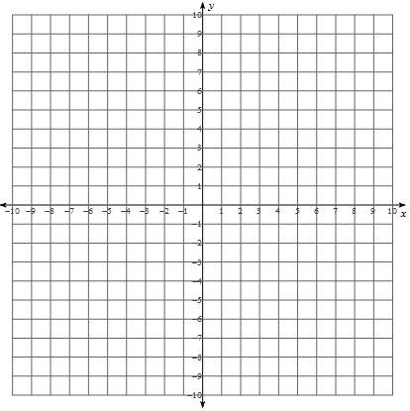

**WORK SPACE**

**c.**) Solve the equation *f*(*x*) = g(x) algebraically.

1. AirBuilder manufactures airplanes. The company does not produce many planes but they are very expensive. Many things effect the cost of doing business including but not limited to building rental, utilities, equipment purchases, supplies needed for construction, employee salaries, and health and dental benefits. The cost of producing *x* planes is given by the polynomial function   
   *c*(*x*) = 0.5*x*4 – 14.5*x*3 + 128*x*2 + 288 where *x* represents the number planes that are produced and *c*(*x*) represents the cost (in millions of dollars) to make *x* planes. The company sells the airplanes for 402 million dollars. By government contract, AirBuilder cannot build more than 17 planes per year.

***GRAPHING*** CALCULATOR ***GRAPHING*** CALCULATOR ***GRAPHING*** CALCULATOR

1. Let *r*(*x*) represent the revenue (total income) the company gets from selling *x* planes. Write the function for *r*(*x*).

**WORK SPACE**

1. Let *p*(*x*) represent the profit the company makes from selling *x* planes. Write a polynomial function for *p*(*x*). Profit = revenue – cost so *p*(*x*) = *r*(*x*) – *c*(*x*).
2. Find the *y*-intercept of the profit function. Explain the meaning of this point in the context of the problem.

.

1. Find the *x*-intercept(s) of the profit function. Explain the meaning of this point in the context of the problem.
2. Harriet Jones is the CEO of AirBuilder. She wants to maximize the profit of the company. How many planes should she plan to construct? What is the maximum possible profit of the company? (You cannot build a fractional component of an airplane.)

**3.** The volume (in3) of a tissue box can be given by the function $V(x)=(8-x)(x+4)(x-1)$.

***GRAPHING*** CALCULATOR ***GRAPHING*** CALCULATOR ***GRAPHING*** CALCULATOR

**a)** Explain why 1 < *x* < 8. (*x* must be greater than 1 and less than 8.) Be very detailed.

(height)

*x* *+ 4*

*x - 1*

(width)

*8 - x*

(length)

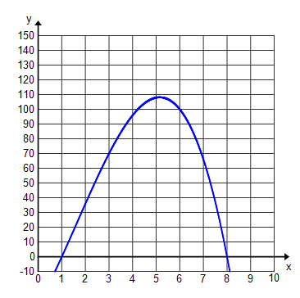**b)** What value of x produces the largest volume of   
 the tissue box? Round to the nearest tenth.

**c)** What is the maximum volume of the tissue box?   
 Round to the nearest tenth.

**d)** What are the **dimensions** of this box with the   
 maximum volume? Round to the nearest tenth.

**e)** Write the equation in standard form.

**f)** What value(s) of x produce a volume of 50 in3? Mark the graph to indicate your findings.   
 (Round to the nearest tenth.)

1. You are building a storage box for your sports equipment. The width of the box is 2 feet less than the height of the box and the length is 5 feet more than the height of the box.



***GRAPHING*** CALCULATOR ***GRAPHING*** CALCULATOR ***GRAPHING*** CALCULATOR

a) Write a polynomial equation representing  
 the volume of the box in standard form.

X



X - 2

X + 5

b) If you need 420 cubic feet of storage, what are the dimensions of the box?



c) In part a) you should have gotten a cubic equation, so why in part b) was there only one solution that you could use. Why could you not use the other solutions?

1. A quadratic equation is given by ${ 5x}^{2}+bx+5=0$

**NO *GRAPHING*** CALCULATOR **NO *GRAPHING*** CALCULATOR **NO *GRAPHING*** CALCULATOR

1. Choose a value for b such that the equation has two real solutions. Explain your reasoning.

**WORK SPACE**

***Leak Rate*** *(gallons/hour)*

1. Choose a value for b such that the equation has two imaginary solutions. Explain your reasoning.

1. Choose a value of b such that the equation has one real solution. Explain your reasoning.

1. Choose a value for b such that the equation could

be solved by factoring.

1. The height of a tossed ball with respect to time can be modeled by the quadratic function

**NO *GRAPHING*** CALCULATOR **NO *GRAPHING*** CALCULATOR **NO *GRAPHING*** CALCULATOR

$h\left(t\right)= -16t^{2}+v_{o}t+ h_{0}$ where: ${ v}_{o}$ = initial velocity $h_{o}$ = initial height

A quarterback throws a football at an initial height of 12 feet with an initial velocity of 80 feet per second.

1. Write an equation that models the height of the football with respect to time.

**WORK SPACE**

***Leak Rate*** *(gallons/hour)*

1. How high is the football after 4 seconds?

1. When will the football be 108 feet high?

**d.)** When will the football reach its maximum height?

What is the maximum height of the football?

**e.)** When will the football hit the ground if no one catches it?